Ex.no:6c | DATA VISUALIZATION USING POWER BI  (GOOGLE PLAYSTORE ANALYSIS)

Aim:
To clean, preprocess, and transform the raw Google Play Store dataset, load the cleaned data into Power BI, and build an interactive visual dashboard to analyze application ratings, reviews, installations, categories, content ratings, and Free and Paid application patterns.
Algorithm:
- Import Dataset: Load Google_Play_Store_Analysis.csv into the environment.
- Deduplication: Identify and delete duplicate rows across all fields.
- Remove Blank Rows: Identify and remove completely blank records from the dataset.
- Handle Missing Values: Identify missing values in each column and replace or remove them appropriately to maintain data consistency.
- Handle Data Type Errors: Convert numerical attributes such as Rating, Reviews, Installs, and Price into appropriate numerical data types.
- Clean Text Data: Remove unnecessary spaces and standardize categorical values such as App, Category, Type, and Content Rating.
- Handle Encoded Categories: Reconstruct the Category attribute from the encoded category columns where required for analysis and visualization.
- Load Clean Data: Load the cleaned Google Play Store dataset into Power BI Desktop using Get Data → Text/CSV and select Transform Data if further cleaning is required.
- Create Core Metrics: Create measures in Power BI to calculate important application metrics.
Output:
1.BAR CHART
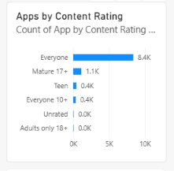
2.Column Chart
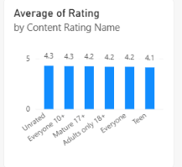

3.Donut Chart
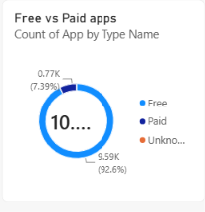
4.KPI CARD
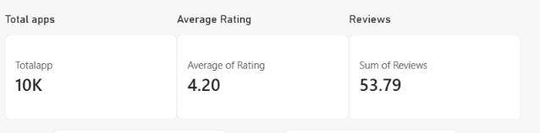
5.Line Chart
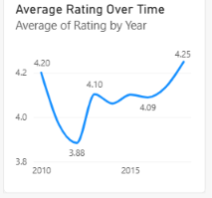

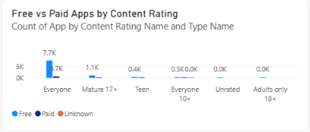
6.Clustered Column Chart

7.DASHBOARD

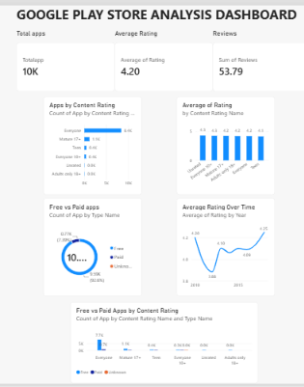

Result:

